**AWS Task-1**

**Task Description:**

Create a windows Vm machine in AWS and connect with RDP open CMD in windows share the about system info.

**Created windows EC2 instance in AWS:**

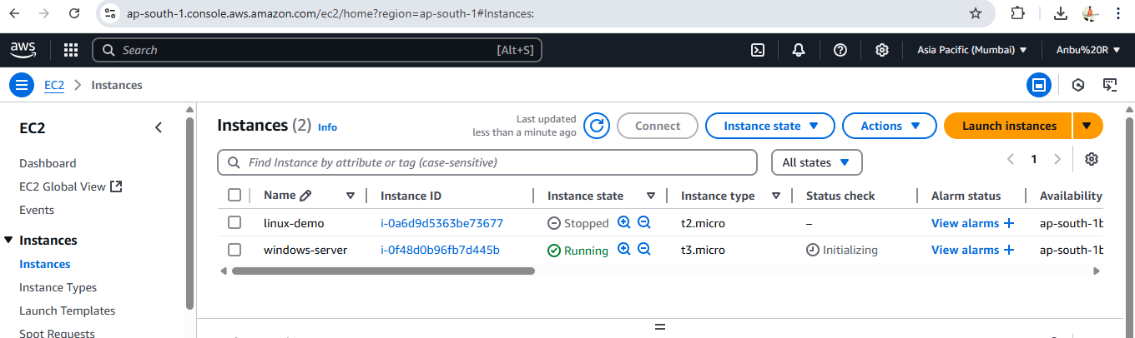

**Decrypt the password using generated windows keypair:**

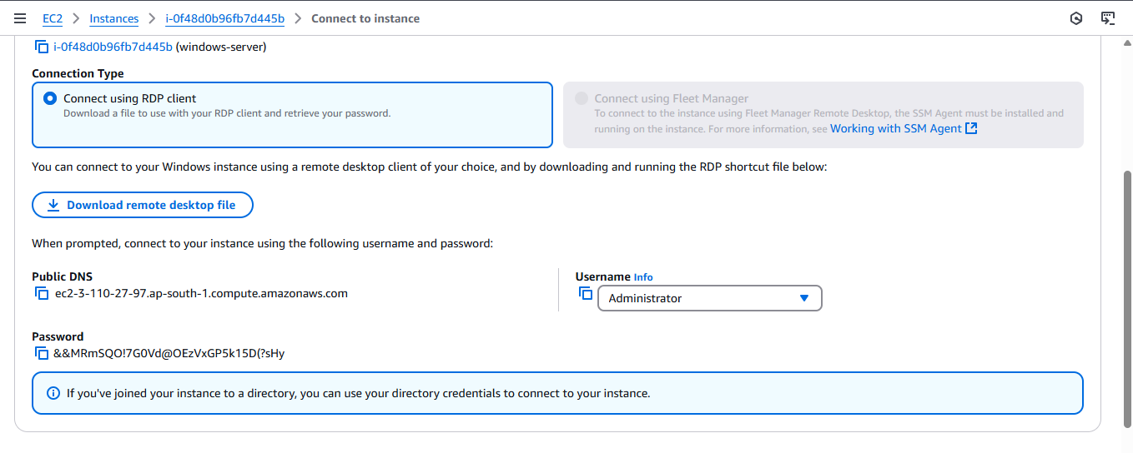

Connect to RDP by giving IP address and credentials

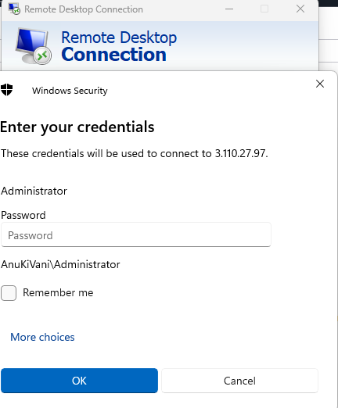

Systeminformation in RDP:

